HERITAGE TOURISM: THE SOWETO HERITAGE TRAIL

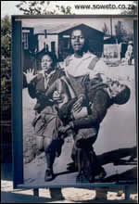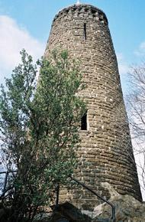[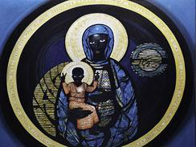](http://showme.co.za/soweto/tourism/regina-mundi-catholic-church/attachment/mary/)

THE GLOBAL TRAVEL AND TOURISM PARTNERSHIP COMPETITION 2016

[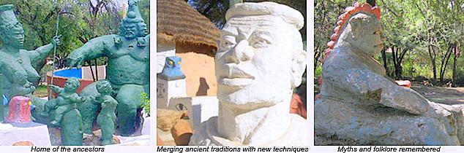](http://showme.co.za/soweto/lifestyle/credo-mutwa-village/attachment/credo1/)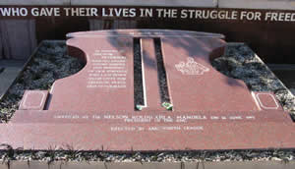

[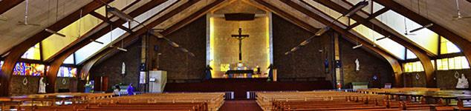](http://showme.co.za/soweto/tourism/regina-mundi-catholic-church/attachment/regina-mundi1/)

CONTENTS

1. Acknowledgements

2. Introduction

3. Literature Review

3.1 Heritage Tourism

3.2 Heritage Trail

4. The story of SOWETO

4.1 Origins

4.2 Struggle against oppression

4.3 The legacy

5. Case study

5.1 Heritage Attractions in Soweto

5.2 Heritage Tourism and sustainability

5.3 Role players responsible for sustainability

6. So Where To: Research Implications

6.1 Challenges

6.2 Benefits

6.3 Recommendations

7. Conclusion

8. Glossary of words

9. Teacher’s Guide

9.1 Work Sheet 1

9.2 Work sheet 2

9.3 Work Sheet 3

9.4 Work Sheet 4

9.5 Work Sheet 5

## 1. Acknowledgements

We would like to thank the Global Tourism and Travel Partnership for providing us with such a great opportunity by allowing us to participate in this prestigious Tourism Conference. We would also like to thank the following partners that work hand in hand with GTTPSA in making this conference a success.



This has helped us in improving our research skills and it also helped us to understand our own history better. We are now in a position to share what we have with the rest of the world. We also would like to thank our Tourism class of 2016 for encouraging us to work harder. Our special thanks go to Faith Mashishi who was selfless and helped us during our research.

We believe that this is a life changing opportunity which will still help a lot of learners like ourselves. This experience we will remain with us for the rest of our lives.

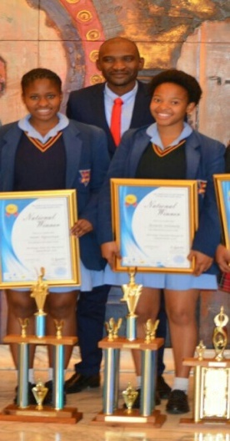

## 2. Introduction

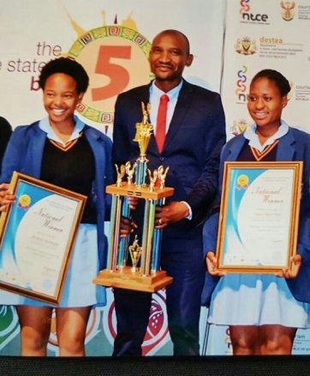

Heritage Tourism Participants 2016

The 2016 winners of the South African leg (Research Competition) from left to right are Boipelo Selemela, Mr Staneford Sithole and Snini Ngwenya from Sandtonview School in Bramley, Johannesburg. They received their prize at Bloemfontein Province in South Africa during the opening of the 2016 National Tourism Career Expo.

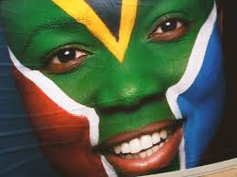

South Africa is one of the richest African countries in the world. Located in Southern Africa it is blessed with a vast amount of wealth. This huge amount of wealth is found in the abundant resources of gold and other precious mineral deposits, agriculture, horticulture, manufacturing, communication and tourism, good weather and wildlife. It is the only country in the world that has 11 official languages. This is because it is made up of diverse cultures that co-exist together in peace. Bishop Desmond Tutu referred coined a nickname and said it is ***‘a rainbow nation’***

South Africa has about 60 million people living in it. Like any other country it is also faced with its own negative issues such unemployment especially of the youth, poverty and inequality just to name a few. The economy has not been doing well as it follows the global economy. It has not attained a reasonable growth since the 2008 global recession. However due to the hosting of the world cup in 2010, South Africa managed to get the recognition that is had needed for a long time.

This was a great opportunity for the country to get the much needed exposure after attaining democracy in 1994.

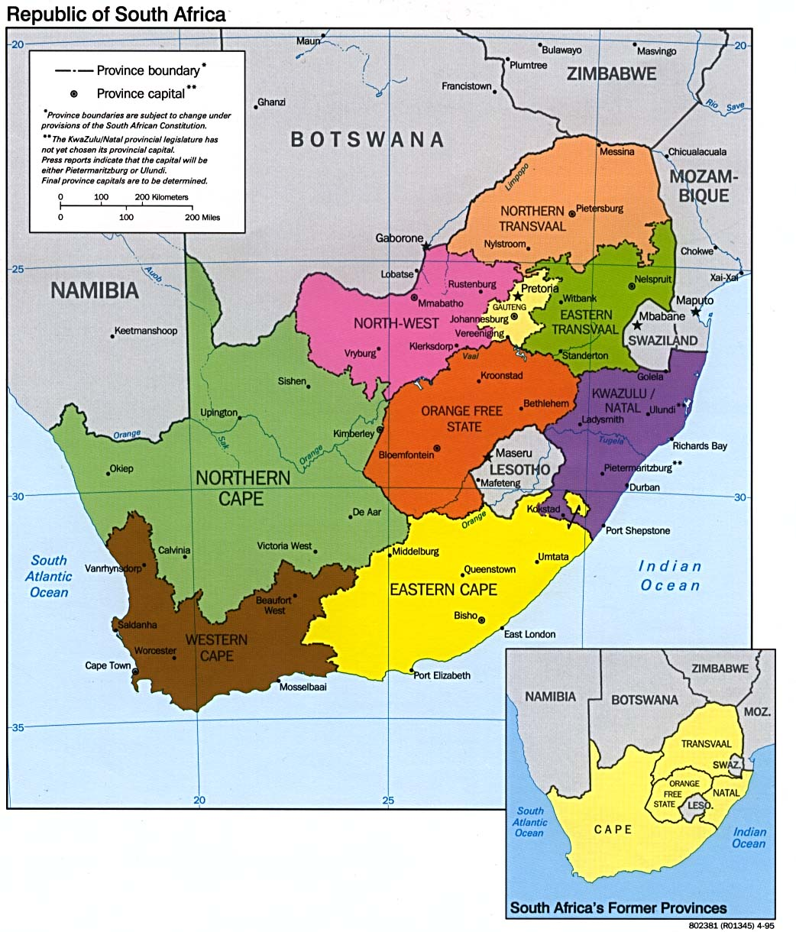

This research was conducted in Soweto, a township found in the South of Johannesburg. Soweto is one of the biggest townships in South Africa with an estimated population of about 2 million people.

## 3. LITERATURE REVIEW

3.1 **Heritage tourism** in South Africa simply means embracing those natural, cultural and other man made attractions, infrastructure and activities that have been handed down from generation to generation with the aim of preserving them for both locals and international visitors to enjoy them. They are the joy and pride of the cities and towns in which they are found in as they tend to define these places in a lot of ways.

Heritage tourism remains untapped in a lot of places as the tourism services providers tend to prioritise heritage sites or their importance only during special holidays. For example in South Africa the Heritage month falls in September. This is the only time when heritage comes to be recognised or realised as significant. Heritage tourism appears to be a niche market in South Africa where it is a preserve of the few.

South Africa is a graced to have 8 World Heritage Sites out of about 1052 in the whole world. South Africa’s cultural diversity, climate and sports and recreation facilities make one of the most visited countries in Africa and also top ranked in the world.

3.2 **Heritage Trail** is a route in a town or city that has a collection of many heritage sites. These can be local or international. They are well preserved and have been or will be handed down from generation to generation. They have a potential of bringing a lot of tourists to the location where they are found.

A heritage trail makes it easy for the visitors to spend time in a certain place. If the places are in close proximity it is more advantageous to the tourists and the local community. Heritage trails thrive in places that have a lot of history because they bring unity to the local communities as they work together to meet the needs of visitors. Heritage trails are laying dormant everywhere and not being recognised. Every community event that is significant to that community has a potential in building up to something that is worth noticing by the whole world. This can happen spontaneously or deliberately when it is planned and officially rolled out.

## 4. The Story of Soweto

4.1 Origins:

**In 1934**

Africans had been drawn to work on the gold mines that sprang up after 1886. From the start they lived in separate areas on the outskirts of Johannesburg, such as Brickfields, also known as Newtown. In 1904 British-controlled city authorities removed Africans and Indians residents of Brickfields to a so called evacuation camp at Klipspruit municipal sewage farm.  The increasing eviction of Africans, following a reported outbreak of bubonic plague led to the formation of **Soweto**. **South West Townships** of Johannesburg were formed, starting with Pimville in 1934 which was part of Klipspruit and then Orlando in 1935.

**1944**

During world war I informal settlements developed to meet the growing lack of housing. This was organised by Sofasonke squatter’s movement which was led by James Mpanza in 1944. They occupied vacant land in what became known as Orlando West. The city council was forced to then set up emergency camps in Orlando, Moroka and Central Western Jabavu.

**1948**

The Afrikaner-dominated National party gained power in 1948 and began to implement apartheid, this increased forced removals and the creation of townships outside legally-designated white areas increased. The Johannesburg council established new townships to the southwest for black Africans evicted from the city’s freehold areas of Martindale, Sophiatown and Alexandra to Diepkloof, Meadowlands, Dube and Rockville.

**1954**

Tladi, Zondi, Dhlamini, Chiawelo, Senaoane were formed,

**1955**

The first hostel to accommodate migrant workers evicted from the inner city was built at Dube.

**1956**

Houses were built in the newly proclaimed townships of Meadowlands and Diepkloof.

In the same year townships were laid out for particular **ethnic** groups as part of the state’s strategy to sift black Africans into groupings that would later form the building blocks of the so-called “independent homelands.” Encouraged by a donation of R6-million to the state by Sir Ernest Oppenheimer for housing in the area

Naledi, Mapetla, Tladi, Moletsane and Phiri were created to house Sotho and Tswana-speakers.

Dhlamini, Senaoane, Zola, Zondi, Jabulani, Emdeni and White City were created for Zulu and Xhosa speakers.

Chiawelo was created to house Tsonga and Venda-speaking residents.

**1963**

The name **Soweto (south western townships)** was officially adopted for the growing township that now occupied what had been the farms of Doornkop, Klipriviersoog, Diepkloof, Klipspruit and Vogelstruisfontein.

## 4.2 The Struggle against oppression

**1976**

On June 16, Soweto came to the world’s attention with the Soweto Uprising, when mass protests erupted over the government’s policy to enforce education in Afrikaans rather than English. Police opened fire in Orlando West on thousands of students marching from Naledi High School to Orlando Stadium. The rioting continued and 23 people, including two white people, died on the first day in Soweto. The first to be killed was Hector Pieterson, who was 12 years old, when the police began to open fire on the students. Another among the killed was Dr. Melville Edelstein, who had devoted his life to social welfare among blacks. The impact of the Soweto protests shook the country and the world. In their aftermath, economic and cultural sanctions were introduced from abroad against South Africa. Political activists left the country to train for guerrilla resistance. Soweto and other townships became the stage for violent state repression. Until this day June 16 is commemorated in South Africa.

In response, the apartheid state started providing electricity to more Soweto homes yet phased out financial support for building additional housing.

[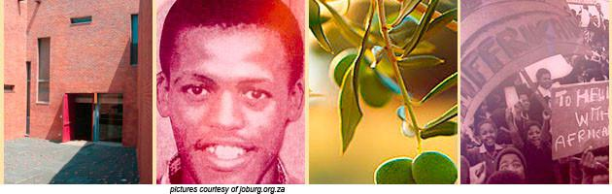](http://showme.co.za/soweto/tourism/museums-in-soweto/attachment/tourism1-2/)

Hector Pieterson Museum showcasing the youth struggle

**1983**

Soweto became an independent municipality with elected black councilors. Previous to that the townships were governed by the Johannesburg council.

Soweto’s black African councilors were not provided by the apartheid state with the finances to address housing and infrastructural problems. Township residents opposed the black councilors as puppet collaborators who personally benefited financially from an oppressive regime. Resistance was increased by the exclusion of blacks from the newly formed Parliament (which included Whites, Asians and Coloureds). Municipal elections in black, coloured, and Indian areas were subsequently widely boycotted, returning extremely low voting figures for years. Popular resistance to state structures dates back to the Advisory Boards (1950) those co-opted black residents to advice whites who managed the townships.

In Soweto, popular resistance to apartheid emerged in various forms during the 1980s. Educational and economic boycotts were initiated, and student bodies were organized. Street committees were formed, and civic organizations were established as alternatives to state-imposed structures. Such actions were strengthened by the call issued by African National Congress’s 1985 Kabwe congress in Zambia to make South Africa ungovernable. As the state forbade public gatherings, church buildings like **Regina Mundi** were sometimes used for political gatherings.

**1995**

Soweto became part of the Southern Metropolitan Transitional Local Council.

**2002**

Soweto was incorporated into the City of Johannesburg. A series of bomb explosions rocked Soweto in October 2002. The explosions, believed to be the work of the Boeremag, a right wing extremist group, damaged buildings and railway lines, and killed one person.

The above events are a testimony of how a small place turned to be such a vibrant area of fighting against oppression of one against the other. Given the size of South Africa as a country, it did not mean that other areas were quiet. It is only because in Soweto and Johannesburg in particular was a cultural melting pot. The discovery of gold in Johannesburg was a huge pulling factor of people from all over the world. Those who had resources wanted to get their hands and control the precious metal at all costs. The minority of people who enjoyed great wealth did not want to share. It can be believed that those who possess the resources at that time possessed the power.

Many educated Africans emerged and this gave a lot of pressure to the Apartheid government to finally give in to first South Africa’s democratically elected government in 1994. This was done after Nelson Mandela one of the African leaders had been in prison for 27years of his life because he wanted to be free and recognised as a person in his own country.

It would be noted again that most of the leaders who contributed to the democracy in South Africa resided in Soweto. These include Nelson Mandela, Arch-Bishop Desmond Tutu, Walter and Albertina Sisulu and many others.

## 4.3 The Legacy

After the attainment of democracy, life had to move on. This means that the whole country had to learn to accommodate each other and live together. There was need for urgent transformation. It wasn’t easy and even 22 years after democracy South African is still in a transition. It was not going to be easy to correct the wrongs that were done in decades but the willingness of people to change and embrace each other counts.

Soweto also evolved. The place that had to be known for the violence and killings, slowly came back to become the pride of the nation. The place that was feared by many as a killing zone became a playground. Today in Soweto you find people from all walks of life and backgrounds laughing and enjoying life together. The infrastructure of Soweto also changed significantly from the squatter camps of the early 1950s to modern housing and other utilities.

Since the end of apartheid in 1994 the Soweto landscape has changed dramatically. Electrical, road and sanitation infrastructure has been upgraded. Parks have been created. Mansions have been built by the rich and famous.

Heritage sites in memory of the struggle years have been created. Restaurants, nightclubs, bed and breakfasts and hotels have sprung up to cater for the growing tourist trade.

The Soccer World Cup spawned the magnificent Soccer City stadium which hosted the opening and the closing of the biggest sporting event in the world.

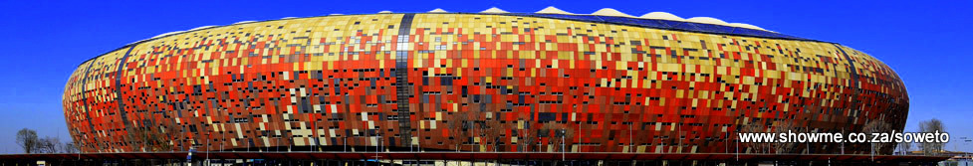

Soccer City in Soweto

The Chris Hani Baragwanath Hospital in Soweto is the largest hospital in the world occupying 173 acres with 3200 beds and 6760 staff members.

[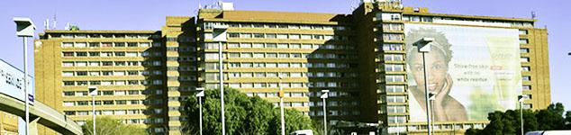](http://showme.co.za/soweto/tourism/1122/attachment/bara-7/)

Chris Hani Baragwanath Hospital

The hospital was built in 1941 to accommodate soldiers from World War II. Field Marshall Jan Smuts noted during the opening ceremony that the hospital would be used for the area’s local black population after the war. Since then the hospital has become one of the most advanced medical facilities in South Africa. In 1997 it was named in honour of the African National Congress leader who was assassinated by white extremists in 1993.

[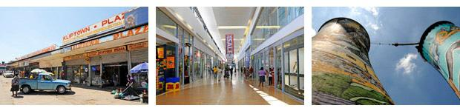](http://showme.co.za/soweto/about-soweto/attachment/soweto-pano-x/)

Maponya Mall and the Cooling Towers

Soweto has become the vibrant trendsetting heart of Johannesburg, the City of Gold. It is a cultural melting pot of about 2 million black people many of whom remain there because of its heritage as the centre of the struggle against apartheid.

There are rumoured to be more millionaires in Soweto than in any other part of South Africa. From the poorer parts such as Kliptown to the upmarket suburb of Diepkloof Extension one can experience the full gift of life in an African “city”. Heritage sites, restaurants, clubs, shebeens (uniquely South African watering holes) and interesting inexpensive accommodation make Soweto a must for tourists to experience the friendship, the contrasts and the friendliness of this unique place.

[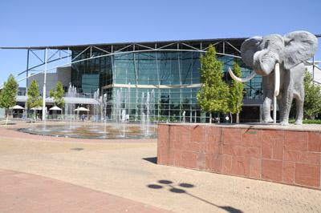](http://showme.co.za/soweto/about-soweto/attachment/soweto-400px/)

Maponya Mall

Soweto is the most metropolitan township in the country and sets the trends in fashion, music and dance as well as in more serious matters such as politics.

The Maponya Mall is on a par with many of the most upmarket shopping malls in South Africa where you will find all of the major local and international brands, restaurants and a cinema complex.

**Shebeens in Soweto**

The word shebeen is derived from ancient Ireland’s speech and it means little mug. A shebeen is place where groups of friends gathered, usually at someone’s home to share drinks and the host would offer food and of course they paid for the drinks. It was an informal bar as liquor was sold without a licence. This term has spread in different countries around the world including South Africa.

Here in South Africa shebeens are often found in townships and were especially so during the apartheid era. Most of them were run by woman who needed to make an income for their families. They started off selling umqombothi, and later on beers and other types of liquor. Shebeens were convenient informal meeting places for some politicians to gather and debate while at the same time listening to some jazz music.

Often times the Shebeen queens and kings would be arrested for a few hours or a few days by the police force if found operating, but as soon as they got back home they operated again despite the warnings they got to never trade without licences again.

In the new South Africa most shebeens operate freely with licences and in **Soweto** they are found on every 3rd or 4th street of every township, but are mostly revamped and refurbished, most of them are now called **taverns or bars** and are open Monday to Monday. The regular patrons are the locals who go there daily to socialise and catch-up with friends after work before going home.

Some clients drink on account, without paying daily, they get a bill every last day of the month and pay for everything they drank, for the past month. In such cases, the shebeen queen keeps a note-book with names, dates, debt amounts and signatures.

## The famous photograph of hector Pieterson being carried after he was shot was taken by Sam Nzima5. Case Study

Hector Pieterson

## 5.1 Heritage Attractions

**The Hector Pieterson Museum**

The Hector Pieterson Museum is a place of memorial that was built to recall the events of 1976. Visitors are taken on a journey that includes the youth rebellion against the repressive government and the events on that fateful day and its aftermath. In 1976 students were protesting against the use of Afrikaans as a medium of instruction in township schools. On their march to Orlando Stadium a 12 year old boy was shot by the police on the 16th of June 1976. This student died in the hands of a fellow student as her terrified sister ran alongside them. Therefore this centre was created as a memorial for this fateful day and a museum was built as a remembrance for this day. This signified a renewed vigour to strengthen the fight against the Apartheid government. The names of all those who died are inscribed in the in the walls on the garden of remembrance. There is a bookshop and also large photographs that depict all the events of the day.

The museum is very famous with people all over the world visiting it. It is the heart of Soweto and will remain so for a very long time. It stands as a symbol of courage that when people stand together how young or old, they can achieve whatever they are fighting against.

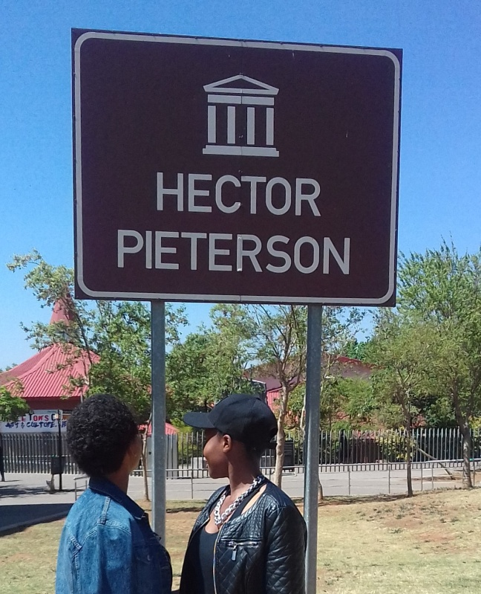

Boipelo and Snini at Hector Pieterson

**Vilakazi Street**

From the Hector Pieterson Museum is a short walk along the tree-lined avenue to the fine restaurants and Mandela House national Heritage site on Vilakazi Street. This is the famous street in the whole world where two Nobel Peace Prize winners once resided. That is Nelson Mandela and Desmond Tutu. Mandela’s house on this street was also turned a museum. This gives an opportunity to visitors to have an insight into this great icon’s life.

Today Vilakazi Street is as ever busy street where internationals and locals alike want to relieve the life of these icons. The street is abuzz with many restaurants that offer traditional and other local cuisines in a ‘kasi’ style. There are live performances by famous local artists. The piece of Nelson Mandela’s life is displayed in the Mandela Museum.

[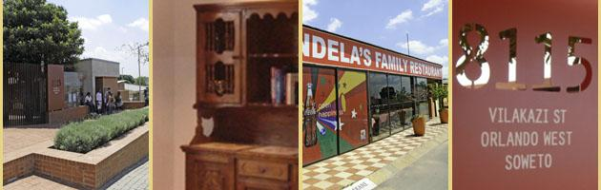](http://showme.co.za/soweto/tourism/museums-in-soweto/attachment/mandela-3/)

Mandela House Museum

The museum is a very interesting stop-over for those wishing to learn more about the world’s most famous former prisoner. It was opened to preserve the history and legacy of the Mandela family. They lived in this house from 1946 until the early 1990’s. The museum tells the story of Mandela’s life at home and on the outside world. This four-roomed museum showcases memorabilia’s, honorary doctorates bestowed upon Mr Mandela by various universities across the world, arts and crafts, world championship belt given to Mr Mandela by Sugar Ray Leonard, paintings and picture collections of his family. The furniture in the house was left as it was when he used to live there. This showcases the typical day in the life of an ordinary man who did lived a selfless and sacrificial life.

The museum does not interfere with the life of the ordinary citizens even though it is situated in the township. It provides an opportunity for the tourists to even interact with some people or families that live (d) as neighbours with the Mandela family. The culture and warmth of the local people makes this place to be a must see or visit in one’s lifetime.

**Regina Mundi Catholic Church**

Regina Mundi Catholic Church in Moroka, Soweto, was built in 1964. Not only is it one of the biggest churches in Africa, but it has a unique history too. It became famous during the apartheid years when it opened its doors to anti-apartheid groups and activists. In those days church services often ended up as political rallies. It continues to play a vital role and remains the spiritual haven for thousands of Sowetans, and it continues to attract tourists from all over the world.

[](http://showme.co.za/soweto/tourism/regina-mundi-catholic-church/attachment/regina-mundi1/)

Regina Mundi Catholic Church

On 16June 1976 protesting students fled to Regina Mundi to escape the police’s bullets and teargas canisters. The police followed the students into the church, firing live ammunition and damaged some of the church’s sacred figures. The bullets’ marks are still evident in the church today. Between 1995 and 1998, part of The Truth and Reconciliation Commission hearings were held in Regina Mundi.

On 30 November 1997, Mr Nelson Mandela paid tribute to the church during a ceremony marking its restoration and established this day as Regina Mundi Day.

In his speech Mr Mandela said Regina Mundi is “a church that refused to allow God’s name to be used to justify discrimination and repression” The most prominent artefacts in the church are, a picture of The Black Madonna depicting a black Virgin Mary holding a black infant, Jesus. It was created in 1973 by Larry Scully as a part of a campaign to raise funds for the education of black South Africans, the second one being its stained-glass windows, decorated with scenery of Mary’s life. These windows were donated by Mrs Jolanta Kwasniewska; wife of the President of the Republic of Poland in 1998.The church’s garden has been transformed into a beautiful park with memorial stones donated by Japanese Christians. Its well manicured lawns join the Thokoza Park.

[](http://showme.co.za/soweto/tourism/regina-mundi-catholic-church/attachment/mary/) [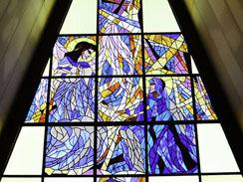](http://showme.co.za/soweto/tourism/regina-mundi-catholic-church/attachment/reg-wind1/)

The Black Madonna Scenery of Mary's Life

In March 1998 Regina Mundi made international headlines when President Bill Clinton and wife Hillary visited the church, and on 22 June 2011, the American first lady, Michelle Obama visited the church and addressed women from different countries.

The A-shaped exterior of the building is quite simple in design compared to most catholic churches. Its main feature is the big interior.

This is a testimony that the church in South Africa has always played an important role in the fight against injustice and it continues to do so. The Regina mundi Church is part of the history of a successful Soweto as well as the nation at large. It deserves the world recognition and heritage status.

**Morris Isaacson High School and June 16 Memorial Centre**

There is also a school called Morris Isaacson, where youth leaders of the struggle against apartheid such as Tsietsi Mashinini once attended. Unfortunately the school has not been given enough attention in its efforts towards the struggle for democracy in South Africa. Learners swapped their uniforms and books to learning new tactics of dodging tear gas and bullets in order to get quality education that will bring about a better life for an African child. The teachers at the school had tried to calm learners down and urged them not to be confrontational with the brutal Apartheid police force. However the students were resolute in their fight for justice.

A memorial acre has been erected in front of the school to commemorate the events of June 16 1976. The Memorial Acre is a community space where a variety of activities take place. These include lectures by different people on issues and challenges facing the youth of today and finding the way forward. It is a meeting place for the youth. Many community events are held in this venue. This venue has a potential of hosting future heritage events given the right marketing. Inside there are displays and pictures of students revolting against the Apartheid government. There are letters that were written by the leaders of the 1976 demonstrations.

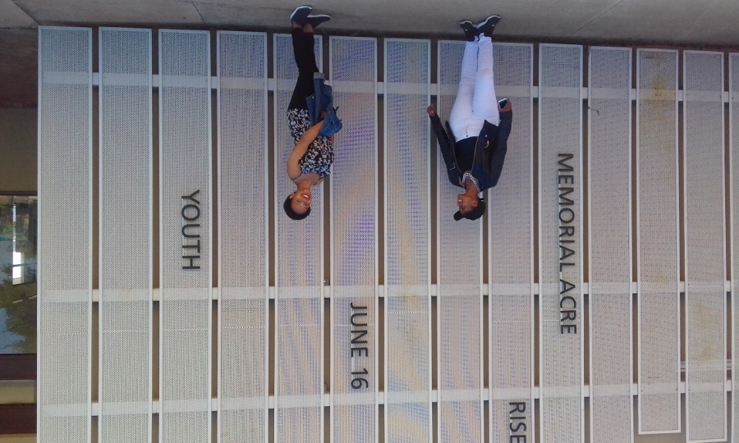

Boipelo and Snini at the Memorial Acre

**Credo Mutwa Village**

In the heart of Soweto, in Central Western Jabavu, a few metres away from the Memorial Acre and Morris Isaacson School lies the endlessly interesting Credo Mutwa Cultural Village. On the corner of Ntsane and Majoeng streets, it is named after the painter, sculptor, environmentalist, herbalist, prophet and author who founded it.

It lies in the landscaped park of the Oppenheimer Gardens; together they offer a relaxed countryside feel in the urban area.

Most of the artefacts in the park were created by Vusamazulu Credo Mutwa, who was born on 21 July 1921 in KwaZulu-Natal. A sangoma and high sanusi, or chosen one, Mutwa is well known and highly respected for his work in nature conservation and as an author of groundbreaking books on African mythology and spiritual beliefs.

[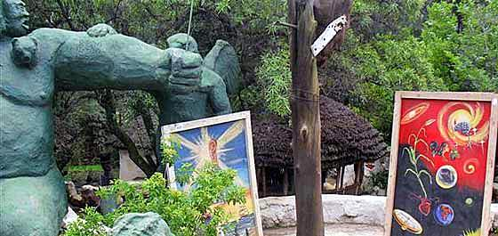](http://showme.co.za/soweto/lifestyle/credo-mutwa-village/attachment/credo11/)

Paintings by Credo Mutwa have been donated by Shelley-Ann Hinks, who believes they should complement the mythological works in the village.

He began work in the park in 1974, continuing for a decade before he left Johannesburg.

Mutwa used a combination of modern and traditional materials including stone, reed thatching, recycled metals and cement, and was helped by a team of assistants he trained. Foremost among his apprentices was traditional artist Musa Ntanzi, who produced a number of the sculptures and structures.

Parts of the cultural village were damaged during the 1976 Soweto Uprising and many of the structures and sculptures fell into disrepair. However, restoration began in 2005 and is proceeding rapidly, returning the site to its former glory.

Now a seasoned artist in his own right, Ntanzi has returned in his middle years to lead the restoration work at the site which he helped to create as a young man.

[](http://showme.co.za/soweto/lifestyle/credo-mutwa-village/attachment/credo1/)

As visitors approach the Khayalendaba, or place of stories, they are met by an ominous notice board that reads:

**“All liars, fools, sceptics and atheists” to keep out. “A curse lasting seven years shall fall on all who destroy any part of this place; they will be unlucky in all they do, be hunted like beasts and finally die in agony in lonely places and the vultures of the sky shall eat their flesh,”**

The place is populated by mythical figures from African cosmology, legendary African warriors and icons of African nationalism. All these are Mutwa’s creations. The most captivating part of the park, the villages are home to Africa’s distinguished ancestors. Through his art, Mutwa has redefined their role in the evolution of African history.

Indigenous god-figures like **Nomkhubulwane,** the female goddess worshipped by the **Nguni** people; and Mvelinqange, a male deity reputedly worshipped in the pre-colonial era, dwarf the other statues.

Next to the Zulu village is the Basotho village, complete with huts and kraals. It tells the story of shepherds playing **morabaraba** – a traditional African board game dating back thousands of years – while guarding their livestock from marauding leopards.

There is also the Arab village, constructed by Mutwa, with oriental architecture and a mosque occupying pride of place.

Prehistoric African mammals – presumably long extinct but brought back to life by Mutwa – include a three-horned beast called “triotribes” and a dragon-like creature called “titamogofaudon”. Relics in the park include a fireplace once used by the prophet to manufacture spears, traditional jewellery and other ornaments.

The Credo Mutwa Cultural Village provides hours of education and entertainment for young and old alike, and is a “must-see” for locals and tourists as there is no any other place like this in the whole of Johannesburg or country. This is only found in Soweto.

**Oppenheimer Tower**

Found at the corner of Majoeng and Ntsane streets in Central Western Jabavu, the many indigenous trees and plants are used by traditional healers in the making of their medicine. Incorporating the Credo Mutwa Cultural Village and Oppenheimer Tower, the Oppenheimer Gardens occupy several hectares.

The park’s many trees give it the appearance of a dense forest, and make it one of the few remaining bird sanctuaries in Soweto. It enhances the relaxed countryside feel of the rocky park, which is rich in flora and fauna. The trees also provide medicine for local herbalists who make use of their bark – *umphafi* is a herb used to fetch the soul of the departed from the spot where they lost their lives, to be taken to their final resting place; and aloe is used to make *timjan* for purifying the blood.

Other traditional African medicinal plants in the park include aloe, cabbage tree, wild olive, *plumbago*, canary creeper, coral tree, Cape honeysuckle and a number of thorn bushes.

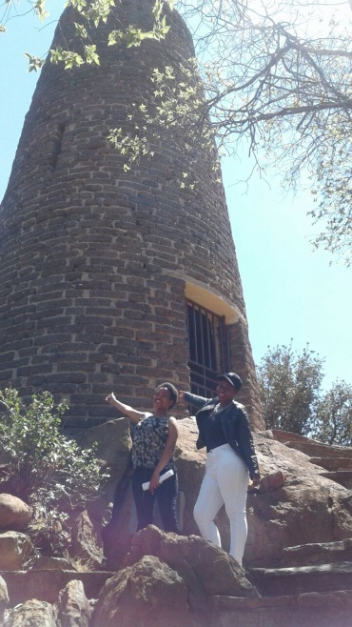

Oppenheimer Tower Boipelo and Snini at the Tower

The historic Oppenheimer Tower, a prominent Soweto landmark, overlooks the gardens. Together the gardens, cultural village and tower make up the key attractions of the Oppenheimer Gardens Public Park and recreation facility.

Strategically located in the centre of Soweto, the tower offers a panoramic bird’s eye view of the sprawling township. It was built in 1957 as a tribute to the contribution of mining magnate Sir Ernest Oppenheimer to alleviating the housing crisis in Soweto.

In 1956, Sir Ernest Oppenheimer visited the desperately overcrowded Shantytown squatter settlement in Orlando and Moroka Emergency Camp. He was moved to arrange for Anglo American and other mining companies to make a substantial loan to the City council to provide housing in Soweto; some 14 000 houses were built with the help of this cash.

The tower was built from bricks from demolished houses belonging to people who were moved to Moroka from newly declared white areas closer to the city.

**Soweto Theatre**

It is a newly built structure that looks 3D in shape. It is situated in Jabulani, a place that has had an infrastructure boost in the last 10 years. It is the first theatre of this type in this area. This theatre reaches out to schools and brings back the life of real theatre. Living in a world that has been overtaken by technology there was a need for people to come back to live performances in Soweto. This place completes the heritage route in this part of Soweto. People from all walk of like come to this place to witness and experience the different themes of stories being showcased. This is a good place that can be used to keep the heritage of Soweto alive through story telling.

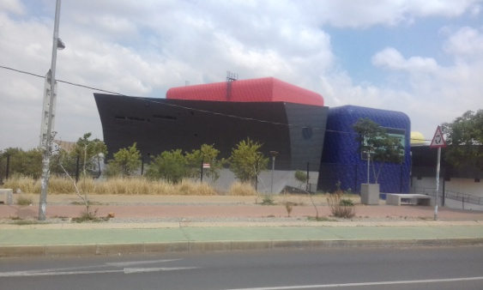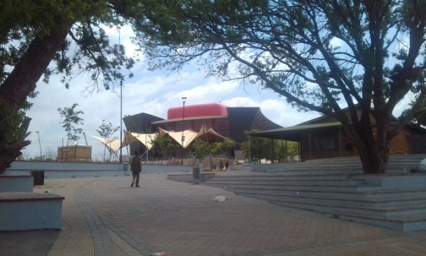

Soweto Theatre

**Soweto Marathon**

This is an ultra-marathon that runs through the heritage sites situated in Soweto. The route of the marathon incorporates the heritage trail. This captures the experience of the whole route in totality. Participants pass through the attractions of the trail in their quest for glory. The participants who take part in the 42km route are the ones that are mostly at the disadvantage of seeing the whole trail.

The event has grown over the years with record numbers of participants taking part. However it has been rocked with challenges because of lack of enough funding. This marathon has a lot of potential to put Soweto on the world map by attracting big names in marathon running. In this way many people will get to know the story of the Soweto Heritage Trail and also experience it. This is a life time opportunity for locals and tourists as well.

Below is a map of the Soweto Marathon. On the map one will identify and locate the different attractions that are part of the Soweto Heritage Trail.

Route of the Soweto Marathon.

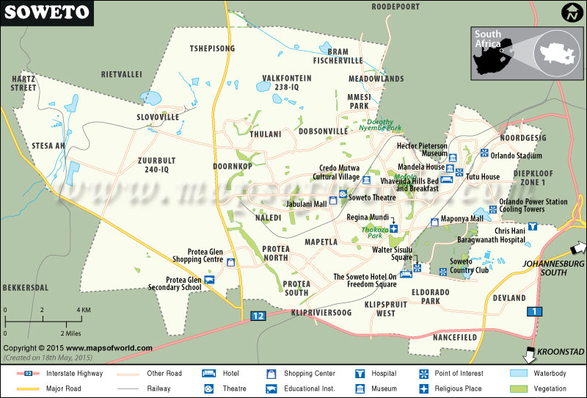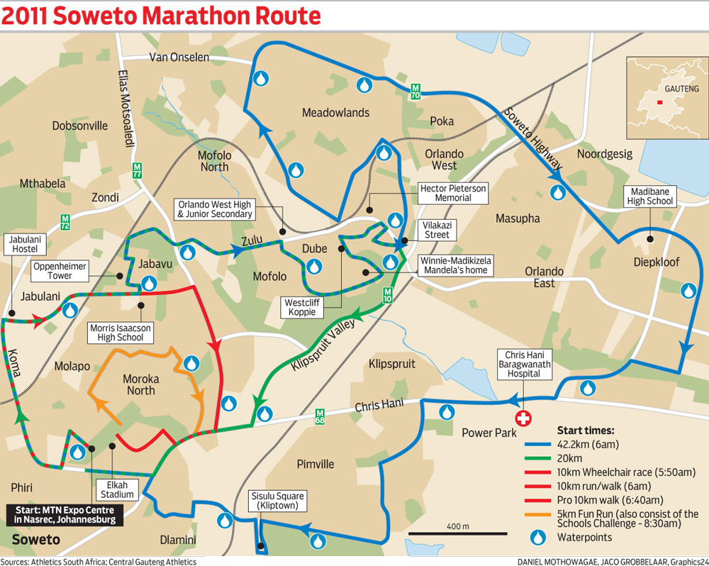

Map of Soweto

## 5.2 Heritage Tourism and Sustainability

What makes this destination to be sustainable is that a day has been set aside as a holiday in South Africa to reflect and appreciate the bravery of the young people of 1976 that contributed a lot to the democracy that we all enjoy as South Africans.

As a result the attractions found along this trail are well kept for both locals and visitors alike as they contain a very important piece of South African History. There are tours that are arranged almost every day by people from all walks of life. This ensures and guarantees that the areas do not become white elephants. The preservation of the areas guarantees the enjoyment of the same history by the future generations. Green tourism is also encouraged in this area so as to keep the place alive for a very long time. There are designated routes for buses, cyclists and people on foot.

Others sites such as the Credo Mutwa village has delicate infrastructure which needs greater amount of care. Security and maintenance are two crucial aspects that need to be upgraded. The story of Soweto needs to be continuously told to all generations in this particular community. People should never ever remain complacent and take their achievements for granted. In this case the endeavours that were taken by those ahead of them will forever be cherished.

## 5.3 Role Players responsible for Sustainability

It is a collective from all the stakeholders to keep this destination sustainable. In South Africa there is an organisation called South African Heritage Resources Agency. It was formed through the National Heritage Resources Act of 1999. It stated that heritage resources should be managed by the levels of government closest to them. Therefore SAHRA is a body that identifies, coordinates and manages the national estate. The Gauteng Provincial Heritage Authority is a regional body that preserves, protects and manage the different heritage sites of Gauteng. It also creates awareness and educates communities about the importance of protecting their resources.

The Gauteng Tourism Authority (GTA) also plays a big role in creating awareness and preserving these sites. The National Heritage and Cultural Strategy of 2012 also provide a framework for the protection of living and non-living heritage. This even goes further down to the municipal level where the local tourism authorities in this case the Soweto Tourism Information Centre. The municipal authorities also maintain the surroundings of the attractions around the heritage trail by looking after the landscape and creating better roads and walking trails.

This will not be complete without the host community playing its role. The community is the one that receives the tourists. They have a say in what goes on around their communities. The success of failure of the Heritage Trail rests with them. As a result the host community ensures that the place is safe for locals and tourists. They can be tour guides around the area. The local members of the community can take opportunities by filling in the gaps that exists and become entrepreneurial. The tourists coming into the place must observe the values and other rules governing the tourist attraction around. The tourists should be mindful that they are in a cultural space of locals and hence should not embark on actions that will antagonise the locals and also place themselves in a position that they fall out of favour with the locals.

## 6. So Where To: Implications of the research

## 6.1 Challenges

Challenges associated with keeping a heritage tourism destination sustainable is lack of involvement of locals in tourism activities. Some of the people were witnesses to the events that unfolded in 1976 however they have not been consulted. Sidelining these people takes away the support towards the tourism attraction by the community and they oppose the activities happening in their area. People can be employed in various businesses from being tour guides to working in restaurants around the area or they can be the service providers. This will allow them to take pride and guarantee the success of the Heritage trail. Some prices being charged by service providers are beyond the reach of the locals as they are aimed at foreign international visitors who bring in their powerful currencies.

Allowing locals affordable entrance and other user fees will go a long way in getting support of the heritage trail and surrounding businesses by the locals. Educating locals about the trail is important as well. Locals must not view the developments as if they are done only for visitors but must view them as part of their livelihood and history. Lack of service delivery protests that often turn violent can also become a repelling factor and turn these areas to be no gone zones by foreign and local visitors. Therefore good governance is a key to continuity and support to this tourism infrastructure in the area. Reliable transport is needed to ferry people from different places to bring them to Soweto.

## 6.2 Benefits

The area of Soweto as a whole benefits from this heritage trail in that, the township is put in the spotlight in the world. Jobs are created whether directly or indirectly especially for the locals. Entrepreneurship opportunities are in abundance as more tourism related businesses can be started. There is pride in the township and a sense of belonging shown by the locals as their area is placed on a global map. Tourists come back to visit the township and the country again. The future generations are able to partake in the history of their forefathers and they preserve it whole heartedly.

There is social cohesion amongst the local people. Development in infrastructure takes place as different facilities are needed for the tourist’s comfort. Besides tourism facilities such as accommodation, restaurants, transport auxiliary services, there is a lot of to social facilities that gets developed as well. Soweto has seen a large number of property developments emerging. People’s standard of living has really improved. There has been another hospital that has been built in Jabulani area. Water, electricity and sanitation are now a problem of the past in Soweto.

## 6.3 Recommendations

For the Soweto Heritage Trail to thrive, a lot more still needs to be done .The infrastructure is available however it needs to be used for the benefit of those who want to come to this place. The bus system is efficient however there are some routes in the heritage trail that are not covered. This in turn takes away a lot of time from the tourist to enjoy and time is spent on getting alternative transport that will take you there. The mini-bus taxi operators need to work together in harmony in providing a flawless operation that will see people especially tourists getting to their desired destinations in a short space of time.

Tour packages that cover the Heritage trail should be developed as part of the township tours. The advantage is that the places are already in close proximity to each other. Adding more activities during the tour will enhance the experience of the tourists. For example in some areas tourists can park their cars in a safe place and either walk or cycle to the next destination. This will allow tourist to meet with locals and get to experience the ‘kasi’ lifestyle. Therefore pamphlets and other promotional methods need to be applied. If the area becomes well known it becomes a one stop destination for different types of tourists.

Having said, the Soweto Tourism Information Centre must be fully involved in the transformation of this area. They need to drum up support for the heritage trail. If a Soweto Heritage Committee can be set up, it will come up with an action plan on how to get the place to be out there in a faster and efficient way. Further research will be carried out by this organisation and provide guidance and direction to the specific attractions on how they can come together and be interlinked.

Safety and security needs to be upgraded. The history of Soweto has put it in disadvantageous position. In some places people still believe that Soweto is a violent place or still unsafe. Measures need to be put in place to ensure and guarantee the safety of visitors. People in Soweto are very friendly and welcoming, the visibility of police and other security structures will provide much needed comfort in the minds of the tourists.

The Soweto Heritage Trail should be included in the list of World Heritage Sites. Some of its attractions such as Vilakazi Street and Hector Pieterson possess qualities that are not found in other attractions. It will be proper and rewarding for a place that has such a huge amount of history.

## 7. Conclusion

The Soweto Heritage Trail is a collection of attractions in Soweto that are in close proximity to each other. What makes this place very special is that these attractions all form part of an important history of South Africa. Soweto is situated in the smallest province of South Africa, but yet contributed so largely to the freedom of the country.

The Soweto Heritage Trail should be given the World Heritage status. The impact that it placed in the whole of South Africa deserves some recognition. These attractions or sites are an evidence of where people have been and how far they have come. The trail shows current generations that indeed the quality of life improved over the years and can still improve further provided tourism takes its place.

One fascinating thing about Soweto is that the boundaries that were created by the government through segregation still remain even though people have been integrated. Soweto remains a tourist attraction that has not been fully exhausted. However, Soweto as a township continues to grow and develop as a residential area. Beside the heritage sites another factor that sells the township of Soweto is the vibrant culture. The people are very friendly and very social.

It is recommended that one should visit Soweto in their lifetime. It is not only enough to hear about Soweto but take the next step and visit the Soweto Heritage Trail. This will be time well spent, enjoyable and educational.

## 8. Glossary of words:

**Apartheid:** A system of oppression and segregation of the black Africans by the Afrikaner government

**Rainbow nation-** A nick name given to South Africa by the Arch-Bishop Desmond Tutu meaning a diverse nation co-existing as equals.

**Heritage tourism** in South Africa simply means embracing those natural, cultural and other man made attractions, infrastructure and activities that have been handed down from generation to generation with the aim of preserving them for both locals and international visitors to enjoy them. They are the joy and pride of the cities and towns in which they are found.

**Heritage Trail** is a route in a town or city that has a collection of many heritage sites/ attractions. These can be local or international. They are well preserved and have been or will be handed down from generation to generation. It is a continuous route from one end to the other.

**Soweto** is an acronym meaning **South West Townships** of Johannesburg were formed, starting with Pimville in 1934

**Coloureds** – an ethnic group in South Africa that is made up of white and black descendants

**Shebeens-** The word shebeen is derived from ancient Ireland’s speech and it means little mug. A shebeen is place where groups of friends gathered, usually at someone’s home to share drinks and the host would offer food and of course they paid for the drinks. It was an informal bar as liquor was sold without a licence. This term has spread in different countries around the world including South Africa.

**‘Kasi’-** is a slang word used by the locals to refer to the township they live in.

**Nomkhubulwane-** the female goddess worshipped by the **Nguni** people

**Mvelinqange**, a male deity reputedly worshipped in the pre-colonial era, dwarf the other statues.

**Nguni-** People who have roots and emerge from Southern Africa

**Morabaraba** – a traditional African board game dating back thousands of years – while guarding their livestock from marauding leopards.

**‘Triotribes’-** a three-horned beast

**“Titamogofaudon”**.a dragon-like creature.

**‘Umphafi’** is a herb used to fetch the soul of the departed from the spot where they lost their lives, to be taken to their final resting place

**‘Timjan’** an aloe is used to make for purifying the blood.

**Sangoma-** An African diviner who can read into people’s lives. This is done by an act of throwing and reading bones.

**Sanusi- Is** an African herbalist. A person who possesses the gift and skill in the use of African medicine.

**Umqomboti-** African traditional beer

## Bibliography

* http//:joburg.org.za/culture
* Via Afrika Tourism Grade 11 Learner’s Book (2012)

D.J Brown and others page 119

* [www.southafrica.net](http://www.southafrica.net)
* [www.showme.co.za](http://www.showme.co.za)

## 9. TEACHER’S GUIDE

The following icons are used to help the teacher and the learners in understanding the work that has been done during the research. Educators are welcome to make any changes that will suit their environment. Teacher’s suggested solutions are given in RED and should not be given to the learners.

|  |  |
| --- | --- |
| 1. **Discussion** | https://d30y9cdsu7xlg0.cloudfront.net/png/89857-200.png |
| 1. **Group Activity** | https://encrypted-tbn3.gstatic.com/images?q=tbn:ANd9GcTmvb5W3o3iVwoibBV6dgGW1cSvmySKmDtq6S6HPelleSIjW6OVN1fL4lQ |
| 1. **Individual Activity** | http://png.clipart.me/graphics/thumbs/214/summer-sports-icon-volleyball-icons_214110949.jpg |
| 1. **Teacher’s suggested solutions** | Two happy stick-people shaking hands |

## http://png.clipart.me/graphics/thumbs/214/summer-sports-icon-volleyball-icons_214110949.jpg9.2 Matching Concepts: Work Sheet 1

Study the words in Column A and match them with the correct descriptions in column B. Write only the number with the correct letter of the alphabet. For example 1.2.11 K

|  |  |  |  |
| --- | --- | --- | --- |
| **No.** | **COLUMN A** |  | **COLUMN B** |
| 1.2.1 | SOWETO | A | One of the largest Catholic Churches that supported the struggle during the 1970s. |
| 1.2.2 | Regina Mundi | B | The only place in the world that is home to two neighbours who are Nobel prize winners. |
| 1.2.3 | Oppenheimer Tower | C | Is a former house of this struggle icon that is meant to show case his life in this township |
| 1.2.4 | Sakhumzi | D | Is a centre constructed in the memory of the first person who became a victim in the 1970s protest against Apartheid. |
| 1.2.5 | Memorial Acre | E | A sangoma and high sanusi, or chosen one, he was well known and highly respected for his work in nature conservation and African mythology and spiritual beliefs. |
| 1.2.6 | Vilakazi Street | F | Built in honour of this man who helped alleviate the housing crisis of Soweto in the 1950s. |
| 1.2.7 | Soweto Theatre | G | Built in honour of the students who perished during the 1970s struggle against oppression. |
| 1.2.8 | Nelson Mandela Museum | H | One of the famous restaurants in Vilakazi Street. |
| 1.2.9 | Hector Pieterson Museum | I | A combination of South Western Townships. |
| 1.2.10 | Credo Mutwa | J | A newly built art centre in Jabulani which is meant to showcase the different talent in the field of arts |
|  |  | K | This is a street where the current president of South Africa resides. |

(1X10)= (10)

9.2 Suggested solutions:

|  |  |  |  |  |
| --- | --- | --- | --- | --- |
| **No.** | **COLUMN A** |  | **COLUMN B** | **Suggested Solutions** |
| 1.2.1 | SOWETO | A | One of the largest Catholic Churches that supported the struggle during the 1970s. | I |
| 1.2.2 | Regina Mundi | B | The only place in the world that is home to two neighbours who are Nobel prize winners. | A |
| 1.2.3 | Oppenheimer Tower | C | Is a former house of this struggle icon that is meant to show case his life in this township | F |
| 1.2.4 | Sakhumzi | D | Is a centre constructed in the memory of the first person who became a victim in the 1970s protest against Apartheid. | H |
| 1.2.5 | Memorial Acre | E | A sangoma and high sanusi, or chosen one, he was well known and highly respected for his work in nature conservation and African mythology and spiritual beliefs. | G |
| 1.2.6 | Vilakazi Street | F | Built in honour of this man who helped alleviate the housing crisis of Soweto in the 1950s. | B |
| 1.2.7 | Soweto Theatre | G | Built in honour of the students who perished during the 1970s struggle against oppression. | J |
| 1.2.8 | Nelson Mandela Museum | H | One of the famous restaurants in Vilakazi Street. | C |
| 1.2.9 | Hector Pieterson Museum | I | A combination of South Western Townships. | D |
| 1.2.10 | Credo Mutwa | J | A newly built art centre in Jabulani which is meant to showcase the different talent in the field of arts | E |
|  |  | K | This is a street where the current president of South Africa resides. |  |

(10)

## http://png.clipart.me/graphics/thumbs/214/summer-sports-icon-volleyball-icons_214110949.jpg9.3 Complete the puzzle:

**Work Sheet 2**

Study the following puzzle and complete by writing the missing words

|  |  |  |  |  |  |  |  |  |  |  |  |  |  |  |
| --- | --- | --- | --- | --- | --- | --- | --- | --- | --- | --- | --- | --- | --- | --- |
|  | 1 |  |  |  |  |  | 2 |  |  | 2 |  | 3 |  |  |
|  |  |  |  |  |  |  |  |  |  |  |  |  |  |  |
|  |  |  |  |  |  | 3 |  |  |  |  |  |  |  |  |
|  |  |  |  |  |  |  |  |  |  |  |  |  |  |  |
|  |  |  |  | 4 | 4 |  |  |  |  |  |  |  |  | 8 |
|  |  |  |  |  |  |  |  |  |  |  |  |  |  |  |
|  |  |  |  |  |  |  |  |  |  | 7 |  |  |  |  |
|  |  | 5 |  |  |  |  |  | 6 |  |  |  |  |  |  |
|  |  |  |  |  |  |  |  |  |  |  |  |  |  |  |
|  |  |  |  |  |  |  |  |  |  |  |  |  |  |  |
|  |  |  |  |  |  |  |  |  |  |  |  |  |  |  |
|  | 5 |  |  |  |  |  |  |  |  |  |  |  |  |  |
|  |  |  |  |  |  |  |  |  |  |  |  |  |  |  |
| 6 |  |  |  |  |  |  |  |  |  |  |  |  |  |  |
|  |  |  |  |  |  |  |  |  |  |  |  |  |  |  |

**Across**

1. Culture that is preserved and handed down from one generation to the next.

2. A slang word used to describe a township.

3. Give the surname of the Arch-bishop who coined the term ‘***rainbow nation’***

4. An acronym for southern western townships

5. This is a school where the 1976 youth uprisings started.

6. These places are similar to taverns and food and drinks are offered to the patrons.

**Down**

1. Write down the name of the first boy to be killed by the police during the 176 youth uprising.

2. Name the province in South Africa where Soweto is located.

3. A famous restaurant situated in Vilakazi Street.

4. This man donated generously to the building of the first houses in Soweto.

5. This man was famous for his work in conservation and African mythology.

6. Name given to a traditional herbalist

7. The youth of 1976 fought against the use of this language as a medium of instruction.

8. This famous sporting event takes place around the Soweto Heritage trail.

**ANSWER TO THE CROSSWORD PUZZLE**

|  |  |  |  |  |  |  |  |  |  |  |  |  |  |  |
| --- | --- | --- | --- | --- | --- | --- | --- | --- | --- | --- | --- | --- | --- | --- |
|  | H | E | R | I | T | A | G | E |  | K | A | S | I |  |
|  | E |  |  |  |  |  | A |  |  |  |  | A |  |  |
|  | C |  |  |  |  | T | U | T | U |  |  | K |  |  |
|  | T |  |  |  |  |  | T |  |  |  |  | H |  |  |
|  | O |  |  | S | O | W | E | T | O |  |  | U |  | M |
|  | R |  |  |  | P |  | N |  |  |  |  | M |  | A |
|  |  |  |  |  | P |  | G |  |  | A |  | Z |  | R |
|  |  | C |  |  | E |  |  | S |  | F |  | I |  | A |
|  |  | R |  |  | N |  |  | A |  | R |  |  |  | T |
|  |  | E |  |  | H |  |  | N |  | I |  |  |  | H |
|  |  | D |  |  | E |  |  | U |  | K |  |  |  | O |
|  | M | O | R | R | I | S | I | S | A | A | C | S | O | N |
|  |  |  |  |  | M |  |  | I |  | A |  |  |  |  |
| S | H | E | B | E | E | S |  |  |  | N |  |  |  |  |
|  |  |  |  |  | R |  |  |  |  | S |  |  |  |  |

**ACROSS**

1. Heritage

2. *Kasi*

3. Tutu

4. Soweto

5. Morris Isaacson

6. Shebeens

**Down**

1. Hector

2. Gauteng

3. Sakhumzi

4. Credo

5. Oppenheimer

6. *Sanusi*

7. Afrikaans

8. Marathon

## https://d30y9cdsu7xlg0.cloudfront.net/png/89857-200.pnghttps://encrypted-tbn3.gstatic.com/images?q=tbn:ANd9GcTmvb5W3o3iVwoibBV6dgGW1cSvmySKmDtq6S6HPelleSIjW6OVN1fL4lQ9.4 Itinerary

**Work Sheet 3**

Work in groups of not more than four. Create a full day itinerary for tourists visiting the Soweto .Heritage trail. Use the following table as a guide. Present your answer to the rest of the class.

***Thomas Jones and Anelisa Tau are friends who met at university. They have now completed their studies and have decided to visit a number of townships they have never been to before. Thomas is 28 years old and comes from Pretoria, He studied law. Anelisa is 26years old from Mahikeng, in North West, she studied Politics and she is keen on knowing about the history of South Africa. They have about R5000 each to spend during their tour in Soweto. They did their tertiary studies at the University of Cape Town. This is where they developed an interest in knowing different cultures. They are also interested in traditional food.***

1. Draw up a tourist Profile for the two people before you create an itinerary that will suit them.

|  |  |  |
| --- | --- | --- |
|  | **Tourist A** | **Tourist B** |
| Photo |  |  |
| Surname |  |  |
| Names |  |  |
| Age |  |  |
| Gender |  |  |
| Profession |  |  |
| Budget |  |  |
| Destination |  |  |
| Number of days to be spent |  |  |
| Interests |  |  |

Itinerary for: Thomas Jones and Anelisa Tau

Date: 20 September 2016

Days: Full Day tour

Types of Tourists: Culture and History

N.B Use the following attractions for your itinerary

**Hector Pieterson Museum, Vilakazi Street, Memorial Acre & Morris Isaacson High School; Credo Mutwa Village and the Oppenheimer Tower and Soweto shebeens**

|  |  |  |  |
| --- | --- | --- | --- |
| Time | Place | Activity | Additional information |
| 08:00 -09:30 |  |  |  |
| 10:00-12:00 |  |  |  |
| 13:30-14:00 |  |  |  |
| 14:30- 16:30 |  |  |  |
| 17:00- 18:00 |  |  |  |



Suggested Solutions

Work in groups of not more than four. Create a full day itinerary for tourists visiting the Soweto Heritage trail. Use the following table as a guide.

1. Draw up a tourist Profile for the two people before you create an itinerary that will suit them.

***Thomas Jones and Anelisa Tau are friends who met at university. They have now completed their studies and have decided to visit a number of townships they have never been to before. Thomas is 28 years old and comes from Pretoria, He studied law. Anelisa is 26years old from Mahikeng, in North West, she studied Politics and she is keen on knowing about the history of South Africa. They have about R5000 each to spend during their tour in Soweto. They did their tertiary studies at the University of Cape Town. This is where they developed an interest in knowing different cultures. They are also interested in traditional food.***

|  |  |  |
| --- | --- | --- |
|  | **Tourist A** | **Tourist B** |
| Photo | Any relevant Picture | Any relevant Picture |
| Surname | Jones | Tau |
| Names | Thomas | Anelisa |
| Age | 28 | 26 |
| Gender | Male | Female |
| Profession | Lawyer | Political Analyst |
| Budget | R5000 | R5000 |
| Destination | Soweto | Soweto |
| Number of days to be spent | Full Day tour | Full day tour |
| Interests | Culture, traditional food | History, culture and traditional food |



Suggested solution for the Itinerary

Itinerary for: Thomas Jones and Anelisa Tau

Date: 20 September 2016

Days: Full Day tour

Types of Tourists: Culture and History

|  |  |  |  |
| --- | --- | --- | --- |
| Time | Place | Activity | Additional information |
| 08:00 -09:30 | Hector Pieterson Museum | Arrival at the Museum. Relieve the lives of the students who rose against the Apartheid Police force in 1976. Watch the videos of the events as they unfolded | * Pay entrance fee |
| 10:00-12:00 | Vilakazi Street | Take a walk from the Hector Pieterson Museum to Vilakazi Street. Visit the Mandela family House Museum and get to experience the first had information about the life of this icon. Meet and greet with the locals if interested. There is a chance to purchase some locally produced artefacts.  ***Lunch served immediately after the tour*** | * Pre-booked lunch will be served at the Sakhumzi restaurant |
| 13:30-14:00 | Memorial Acre & Morris Isaacson High School | Pass through the school where protests started. Across the road you can view the different weaponry that was used by both the students and the police in their running battles. | * Note that the school is still operational and will not be open to the public except by appointment. |
| 14:30- 16:30 | Credo Mutwa Village and the Oppenheimer Tower | You have an option of using a car or continue to walk to the Village and the tower. Explore the African mythology as according to Credo Mutwa. The guide will explain the statues and the paintings on the site. Explore some cultural villages found there.  Go up the Oppenheimer tower and have a 360 degrees view of Soweto. | * Adhere to the given instructions in the village |
| 17:00- 18:00 | Soweto shebeens | This will be your last stop before the end of the tour. Experience traditional cuisine as well as traditional drinks and beer. Meet the locals and enjoy local entertainment. | * Enjoy traditional beer but don’t consume it in excess. |

## http://png.clipart.me/graphics/thumbs/214/summer-sports-icon-volleyball-icons_214110949.jpgMap Work

**Work Sheet 4**

Study the Map of Soweto carefully and answer the questions that follow.



1. Copy the map and use a coloured pen to draw the Soweto Heritage trail starting from Hector Pieterson Museum.

2. Identify and write down places where tourists can be accommodated in the area.

3. Give the direction of Chris Hani Baragwanath Hospital from Credo Mutwa Village

4. Identify and write down the recreational parks that tourists and locals can use.

5. What type of a map is this?

Suggested Solutions

Study the Map of Soweto carefully and answer the questions that follow.



1. Copy the map and use a coloured pen to draw the Soweto Heritage trail starting from Hector Pieterson Museum.

Learners need to produce a circular route involving the attractions that make up the heritage site.

2. Identify and write down places where tourists can be accommodated in the area.

a) Vhavenda Hills B&B

b) Soweto Hotel on Freedom Square

3. Give the direction of Chris Hani Baragwanath Hospital from Credo Mutwa Village

South East

4. Identify and write down the recreational parks that tourists and locals can use.

Dorothy Nyembe Park,

Mofolo Park,

Thokoza Park

5. What type of a map is this?

Tourist information map

**Case Study: Work Sheet 5**

Read the time line on the history of Soweto and answer the following questions.

Africans had been drawn to work on the gold mines that sprang up after 1886. From the start they lived in separate areas on the outskirts of Johannesburg, such as Brickfields, also known as Newtown. In 1904 British-controlled city authorities removed Africans and Indians residents of Brickfields to a so called evacuation camp at Klipspruit municipal sewage farm.  The increasing eviction of Africans, following a reported outbreak of bubonic plague led to the formation of **Soweto**. **South West Townships** of Johannesburg were formed, starting with Pimville in 1934 which was part of Klipspruit and then Orlando in 1935.

The Afrikaner-dominated National party gained power in 1948 and began to implement apartheid, this increased forced removals and the creation of townships outside legally-designated white areas increased. The Johannesburg council established new townships to the southwest for black Africans evicted from the city’s freehold areas of Martindale, Sophiatown and Alexandra to Diepkloof, Meadowlands, Dube and Rockville.

In the same year townships were laid out for particular **ethnic** groups as part of the state’s strategy to sift black Africans into groupings that would later form the building blocks of the so-called “independent homelands.” Encouraged by a donation of R6-million to the state by Sir Ernest Oppenheimer for housing in the area

Naledi, Mapetla, Tladi, Moletsane and Phiri were created to house Sotho and Tswana-speakers.

Dhlamini, Senaoane, Zola, Zondi, Jabulani, Emdeni and White City were created for Zulu and Xhosa speakers.

Chiawelo was created to house Tsonga and Venda-speaking residents.

The name **Soweto (south western townships)** was officially adopted for the growing township that now occupied what had been the farms of Doornkop, Klipriviersoog, Diepkloof, Klipspruit and Vogelstruisfontein in 1963

Soweto was incorporated into the City of Johannesburg. A series of bomb explosions rocked Soweto in October 2002. The explosions, believed to be the work of the Boeremag, a right wing extremist group, damaged buildings and railway lines, and killed one person.

1. What was a pull factor of migrants into the city of Johannesburg? (2)

2. Explain the reason that led to the forcible removal of Africans and Indians from the city centre? (3)

3. Do you think that this action by the British Authorities was fair on the Africans and Indians? (3)

4. In Your own understanding explain the policy of Apartheid that was enforced by the Afrikaner Authorities. (3)

5. Identify the various ethnic groups that were the government used to divide the land set aside for the African people. (6)

6. Why do you think that the Boeremag continued to attack black Africans in 2002? (3)

**(20)**



7. Conduct a class discuss the lessons that can be drawn from the struggle of the Sowetans.

8. Conduct a discussion on the contribution of this history in the development of Tourism in Soweto.

**Case Study: Work Sheet 5 (Suggested Solutions)**

Read the time line on the history of Soweto and answer the following questions.

***Africans had been drawn to work on the gold mines that sprang up after 1886. From the start they lived in separate areas on the outskirts of Johannesburg, such as Brickfields, also known as Newtown. In 1904 British-controlled city authorities removed Africans and Indians residents of Brickfields to a so called evacuation camp at Klipspruit municipal sewage farm.  The increasing eviction of Africans, following a reported outbreak of bubonic plague led to the formation of Soweto. South West Townships of Johannesburg were formed, starting with Pimville in 1934 which was part of Klipspruit and then Orlando in 1935.***

***The Afrikaner-dominated National party gained power in 1948 and began to implement apartheid, this increased forced removals and the creation of townships outside legally-designated white areas increased. The Johannesburg council established new townships to the southwest for black Africans evicted from the city’s freehold areas of Martindale, Sophiatown and Alexandra to Diepkloof, Meadowlands, Dube and Rockville.***

***In the same year townships were laid out for particular ethnic groups as part of the state’s strategy to sift black Africans into groupings that would later form the building blocks of the so-called “independent homelands.” Encouraged by a donation of R6-million to the state by Sir Ernest Oppenheimer for housing in the area***

***Naledi, Mapetla, Tladi, Moletsane and Phiri were created to house Sotho and Tswana-speakers.***

***Dhlamini, Senaoane, Zola, Zondi, Jabulani, Emdeni and White City were created for Zulu and Xhosa speakers.***

***Chiawelo was created to house Tsonga and Venda-speaking residents.***

***The name Soweto (south western townships) was officially adopted for the growing township that now occupied what had been the farms of Doornkop, Klipriviersoog, Diepkloof, Klipspruit and Vogelstruisfontein in 1963***

***Soweto was incorporated into the City of Johannesburg. A series of bomb explosions rocked Soweto in October 2002. The explosions, believed to be the work of the Boeremag, a right wing extremist group, damaged buildings and railway lines, and killed one person.***

1. What was a pull factor of migrants into the city of Johannesburg? (1)

The discovery of gold in the Johannesburg

2. Explain the reason that led to the forcible removal of Africans and Indians from the city centre? (3)

It was because of the reported outbreak of bubonic plague, and to crush competition for the newly found gold.

3. Do you think that this action by the British Authorities was fair on the Africans and Indians? (2)

It was not fair because it wasn’t done with their approval and consent.

(Any other relevant answer)

4. In Your own understanding explain the policy of Apartheid that was enforced by the Afrikaner Authorities. (3)

It was a system of separate development that continued the removal of Africans from all suburbs and further divided them according to their ethnic groupings.

5. Identify the various ethnic groups that were the government used to divide the land set aside for the African people. (6)

Sotho, Tswana, Zulu, Xhosa, Tsonga and Venda.

6. Why do you think that the Boeremag continued to attack black Africans in 2002? (3)

They wanted to destabilise Soweto and create an impression that it is a violent place

They wanted to halt the progress and development in Soweto

(Any other relevant answer)



7. Conduct a class discuss the lessons that can be drawn from the struggle of the Sowetans.

(Learners to motivate on their responses and the Educator to guide)

8. Conduct a discussion on the contribution of this history in the development of Tourism in Soweto.

(Learners to identify the positives that have come out from Soweto and how this has boosted tourism)